ImpulseTM Manual

Includes: IMPULSETM and IMPULSE TurboTM




WARNING! The ImpulseTM Paintball Marker is not a toy. Misuse or careless use may cause serious injury or death. The user and any person within range must wear eye protection designed for paintball use. Recommended at least 18 years old to purchase, 14 years old to use with adult supervision, or 10 years old to use on paintball fields meeting ASTM standard F1777-97. Read operation manual before using. Always use barrel plugs when not involved in actual play. When gassing and de-gassing the marker’s system, never aim the gun at another person. Always point the barrel towards the ground. Never use over-filled CO₂ bottles as this will “spike” the system causing the hoses to burst. Do not attempt to lighten or alter trigger assembly in any way, doing so will void your Smart Parts warranty ! This includes any modifications such as: spring removal, installing or adjusting set screws, and/or removing material from the trigger!!!!!!!

Impulse™ Limited Warranty

Smart Parts warrants for 1 year to initial retail purchaser that the Impulse™ paintball marker and regulator are free from defects in materials and workmanship. Disposable parts (batteries, o-rings, seals, etc) are not warranted. The valve and hammer assembly are warranted for six months. The solenoid and electronics on your Impulse™ are unconditionally warranted for six months, plus an additional warranty of six months for electronic parts only (installation and labor are not included.) This warranty does not cover surface damages (scratches and nicks,) misuse, or improper disassembly and re-assembly, or attempts made to drill holes or remove metal from the external surfaces, which could result in degrading the performance and reducing pressure safety factors. Do not use Teflon tape on any part of this marker--the tape can break off and plug the solenoid. Instead, use Loctite 271. Do not make changes to the basic marker parts without written approval. The only authorized lubricant for the gun is DOW 33 Lubricant. Use of any other lubricant could result in voiding your warranty. Use only those “on/off” switches purchased from Smart Parts. Unauthorized “on/off” switches will void this warranty. Paintball markers non-refundable. This warranty is limited to repair or replacement of defective parts with the customer to pay shipping costs. This warranty is effective only if the customer returns the warranty registration card enclosed with the marker. The warranty is non-transferable. Do not attempt to alter the trigger assembly in any way, as this will void your Smart Parts warranty. Trigger alteration of any kind may result in serious injury!

Thank you for purchasing the Impulse™. The Impulse™ is the culmination of years of research and testing. Engineers at Smart Parts, building on their experience with the original Shocker and the Shocker Sport™ now introduce a smaller compact design to keep up with the demands of today’s players and the quality you expect from Smart Parts, Inc. We’ve made the Impulse™ smaller and lighter than the Shocker while keeping the low pressure, accuracy and extremely low ball breakage! In addition, we’ve upgraded the electronics, wiring and grounding to make the marker very reliable. The Impulse™ incorporates a digital circuit board, high flow bolt and valve assembly, and a simplistic design to provide outstanding performance at an affordable price.
THE BASICS

The Impulse™ consist of three main assemblies: the Body, the Solenoid Housing, and the Grip Frame.

Body

The Body is two inter-linked systems, the Bolt and the Firing System. It also includes an air transfer port.
The Bolt is contained in the upper chamber and can be removed by simply pulling out the bolt location pin (#414) and sliding the bolt from the rear end of the body. The Bolt is operated by the hammer and is connected by the bolt pin. The bolt’s function is to load the paintballs into the breach of the gun and to transfer the air from the valve to the ball in order to propel it.
The firing system is essentially the cycling of the hammer mechanism. The hammer is controlled by the solenoid valve which when activated starts the firing cycle. The forward action of the hammer drives the bolt forward to push a paintball from the breach area into the barrel while at the same time the hammer strikes the valve assembly to allow the air burst to expel the paintball from the barrel. The rearward cycle of the hammer allows the valve assembly to close while also opening the bolt to allow a paintball to drop into the breach area.
The vertical entry 1/8” N.P.T. air transfer port distributes air to the entire gun. This also contains a gun filter (note: the impulse filter is shorter in length than the Shocker filter). Clean the filter every six (6) months with alcohol.

Solenoid Housing

The solenoid housing serves three functions. First it encloses and protects the solenoid, secondly it holds the circuit board and third it connects the body and the grip frame. The solenoid housing is held to the body using two 1/4”-20 allen head cap screws. It is important not to over tighten these screws as thread damage may occur. The circuit board is mounted to the solenoid housing using screws and should not be removed or adjusted. The circuit board is coated with a water-repellent coating to prevent problems in wet playing conditions. The timing of the gun is preset at the factory.
A small green LED is located on the back of the solenoid housing. This is the battery life indicator. It will light up continuously when the battery needs replaced. The LED is also used to indicate the positioning of potentiometer “pot” switches (see diagram on page 8). When the Impulse is turned “ON” the LED will proceed through an initial lighting sequence of green and orange and will also light green to indicate when the gun is fired.
If you have purchased an Impulse™ Turbo, your solenoid housing will have a 3-way switch protruding from the right of the LED. This is the Turbo Mode switch. It allows you to select between Semi-Automatic and Turbo. With the switch in the center position the gun is in Semi-Automatic mode. Moving the switch to the left or right position when you are facing the back of the gun sets Turbo mode.
The switch cover provided with the Impulse Turbo™, does not allow the modes to be changed during play.

Grip Frame
The Grip Frame contains the trigger and battery. It is held to the solenoid housing with two 1/4"-20 screws. The batteries are replaceable standard 9 volt alkaline. NOTE: It is highly recommended that you turn off your on/off switch after each day of play. This will greatly extend the life of the battery—if you do not turn off your battery the power will slowly drain. With normal care and usage the batteries should last at least 50,000 shots. There are holes on the bottom of the grip frame for a standard bottom line fitting.

General Cleaning and Lubrication

The body of the gun should be cleaned off with a damp cloth. In the unlikely event of a ball break, the bolt can be removed and a squeegee can be run through the entire upper chamber to clean out the paint residue. DO NOT run the gun under water to clean out broken paint.
If you should ever lose or damage an o-ring or seal in your Impulse or your Impulse regulator you may purchase o-ring kits from Smart Parts. They are available in partial and complete kits for both the Impulse regulator and the gun.
Your Impulse will need to be disassembled and re-lubricated with a LIGHT coat of Dow Corning 33 grease after each day of play! The main parts that need greased are the bolt and the valve. Proper lubrication is vital to the performance of your Impulse. If it is not lubricated thoroughly it will not perform at its optimum level! This may also result in premature failure of the o-rings.
To lubricate the bolt you must remove the bolt location pin and slide the bolt from the rear of gun. Then using your finger work a small amount of grease onto the bolt. After this is done work the bolt head back and forth to distribute the grease throughout the assembly. When reinstalling the bolt location pin through the bolt for re-assembly, the bolt must be in the back position to allow the pin to fit into the hammer.
IMPORTANT: when reinstalling the bolt, be sure the air transport hole is facing down !!

To lubricate the hammer (sa2), first remove the bolt location pin (414) and bolt (sa1). Then using a 7/8” AF wrench, remove the hammer assembly (sa2) located in the rear of the gun below the bolt. With the hammer assembly removed, wipe off all old grease and replace with a generous coating to the o-rings and the hammer piston. Do not apply grease to the hammer itself! Work grease into the air passages of the hammer housing and cycle hammer back and forth to distribute the grease. After this is done replace the hammer and hammer housing followed by the bolt and bolt location pin.
To lubricate the valve, first remove the valve end cap (412) by simply unscrewing with a wrench. Next, remove the valve spring and sliding out the valve. Once removed, wipe off old grease and replace with a generous amount of Dow 33 grease.

Battery Pack Removal and Replacement

The battery pack is located in the grip frame and can be replaced easily. In order to change the battery pack one side of the grip must be removed. To do this you must use a Phillips head screwdriver and remove the two screws in the side of the grip frame holding the grip on. Once this is done you can pull the grip back and see the battery pack. Disconnect the battery pack by simply unplugging the connector-plug. Note: It is important that the on/off switch be turned off after each day of play.

Disassembly of the Impulse™

Before attempting any disassembling of the Impulse™: remove all sources of paint and air, remove the barrel, and disconnect the battery pack. Failure to follow these precautions may result in damage to the gun and/or  grievous injury  to operator or bystanders.
NOTE: A general universal wrench is available for both the IMPULSE and the SHOCKER, to aid in both assembly and disassembly.
The disassembly of the Impulse™ into its three main parts is easy. Usually it is not necessary to remove the grip frame and the solenoid housing from the body to do normal maintenance of the components in the body. If you need to access the body or hammer assembly (sa2) skip down to the second paragraph in this section.
The first step is to remove the grip frame from the solenoid housing. This is done using a 1/8” Allen wrench to loosen and remove the two grip frame screws (#429) holding the parts together. The battery pack must also be disconnected from the circuit board. The next step is to separate the solenoid housing from the main body. Once this is done the solenoid must be disconnected from the circuit board. Disconnecting the solenoid is accomplished by unplugging the connector from the board itself. Now you have separated the gun into its three main parts. NOTE: when the solenoid housing is separated from the body, the ON/OFF switch will move freely (carefully set aside so as to not misplace the switch).
The body of the gun is the only part that can really be disassembled any further. The first and easiest part to remove is the bolt. To remove the bolt, simply grasp the bolt location pin (414) and pull out, once this is removed, the bolt is no longer connected to the hammer. A schematic of the bolt and its replacement seals is shown on page 10.
The next step is to remove the hammer (sa2). This is located beneath the bolt in the back of the gun. The hammer assembly is removed using a flat head screwdriver, once the threads are out the part can be removed by simply pulling on it. The hammer assembly is shown on page 10.
The valve assembly is the next part that can be remove from the marker body. The valve assembly is located in the front of the gun below the barrel. You must first remove the valve end cap by using a wrench, you will then slide out the valve spring and valve. The valve is shown on page 10.
The solenoid can be removed from the body by unscrewing the two mounting screws. Note: We highly recommend you DO NOT attempt to remove the solenoid because the mounting threads are easily stripped. If the threads become stripped you must purchase a new body.

The Circuit Board

The circuit board for the Impulse™ controls the Dwell setting and the fire rate of the gun. The circuit board also features a built in safety switch (battery on/off switch). Two different circuit boards are available for the Impulse, the basic™ and the Turbo™ board. The Turbo™ board allows for an impressive fire rate.
Another option available through Smart Parts is the VL Revolution loader kit. This loader kit allows you to upgrade your Revolution loader. Instead of being controlled by the seeing eye, the loader is controlled by the trigger pull of the Impulse Turbo™. The new loader also has a speed adjustment feature, which allows you to adjust the speed of the motor in your loader. This loader also has a battery saving feature that can extend the life of your loader batteries.
A picture of the circuit board is shown at the end of this section. Your Impulse™ has been factory set for optimum performance with a proper Dwell setting. In the unlikely event that your Impulse™ needs fine-tuning, an adjustment pot switch has been provided for the Dwell setting on the right hand side of the gun. The pot switch has the ability to increase or decrease the Dwell setting (see instructions on next page).

Important: The Dwell setting is pre-set for each gun before it leaves the factory. Be sure that there are no mechanical problems with the gun such as: worn bolt (or bolt o-rings), un-greased parts, misplaced o-rings, low battery, dirty solenoid spool, or a clogged pilot in the solenoid. All of these circumstances could produce symptoms of an improper Dwell setting. It is highly suggested to first clean all parts including the solenoid before altering the Dwell setting on a circuit board. for solenoid cleaning instructions and illustrations, see Smart Parts web site.

Start with the battery connected; power to the board, and a pressurized gas system.
Be sure that you have a good battery and a completely full tank.
You must also be using a full 12-volt revolution loader with good batteries!!
Note: Paintballs must be properly sized for your barrel when positioning the Dwell setting!

- You will need to then adjust the inlet pressure of the gun to a desired setting between
170psi and 190psi. WARNING ! DO NOT EXCEED 200 PSI FOR AN INLET PRESSURE, AS THIS CAN CAUSE DAMAGE TO THE SOLENOID.
- With the proper inlet pressure, adjust Dwell clockwise until dramatic velocity reduction is noticed. At this point increase the Dwell setting (counter clockwise rotation) until the gun shoots properly with a consistent velocity.
NOTE: the Dwell “pot” switch can be accessed through a small hole on the right hand side of the gun.

Velocity Adjustment

The velocity of the Impulse™ in controlled by both the pressure going into the gun and the Dwell setting. This pressure, and in turn the velocity, is adjusted at the regulator. To adjust the velocity you must turn the spring housing on the regulator. The spring housing is the long black cylinder on the regulator with a hex nut at the top and a hole drilled in the bottom. To increase the velocity you must turn the spring housing in or clockwise. Caution: Do not increase the pressure over 200 psi. This will cause the solenoid to leak and the hose may burst. To decrease the velocity you must turn the spring housing out or counter clockwise. Once you have the velocity adjusted to where you want it, you should lock down the lock nut and re-chronograph your marker. Note: In order to get the proper velocity reading from your Impulse™ you must point the barrel up when shooting across the chronograph.

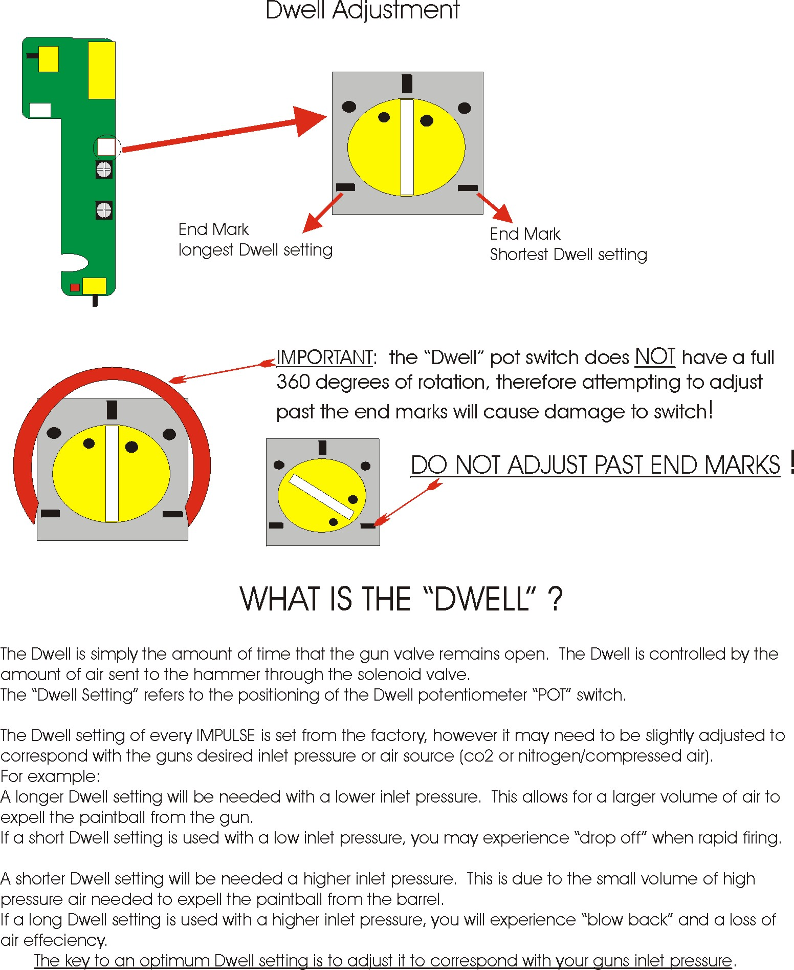
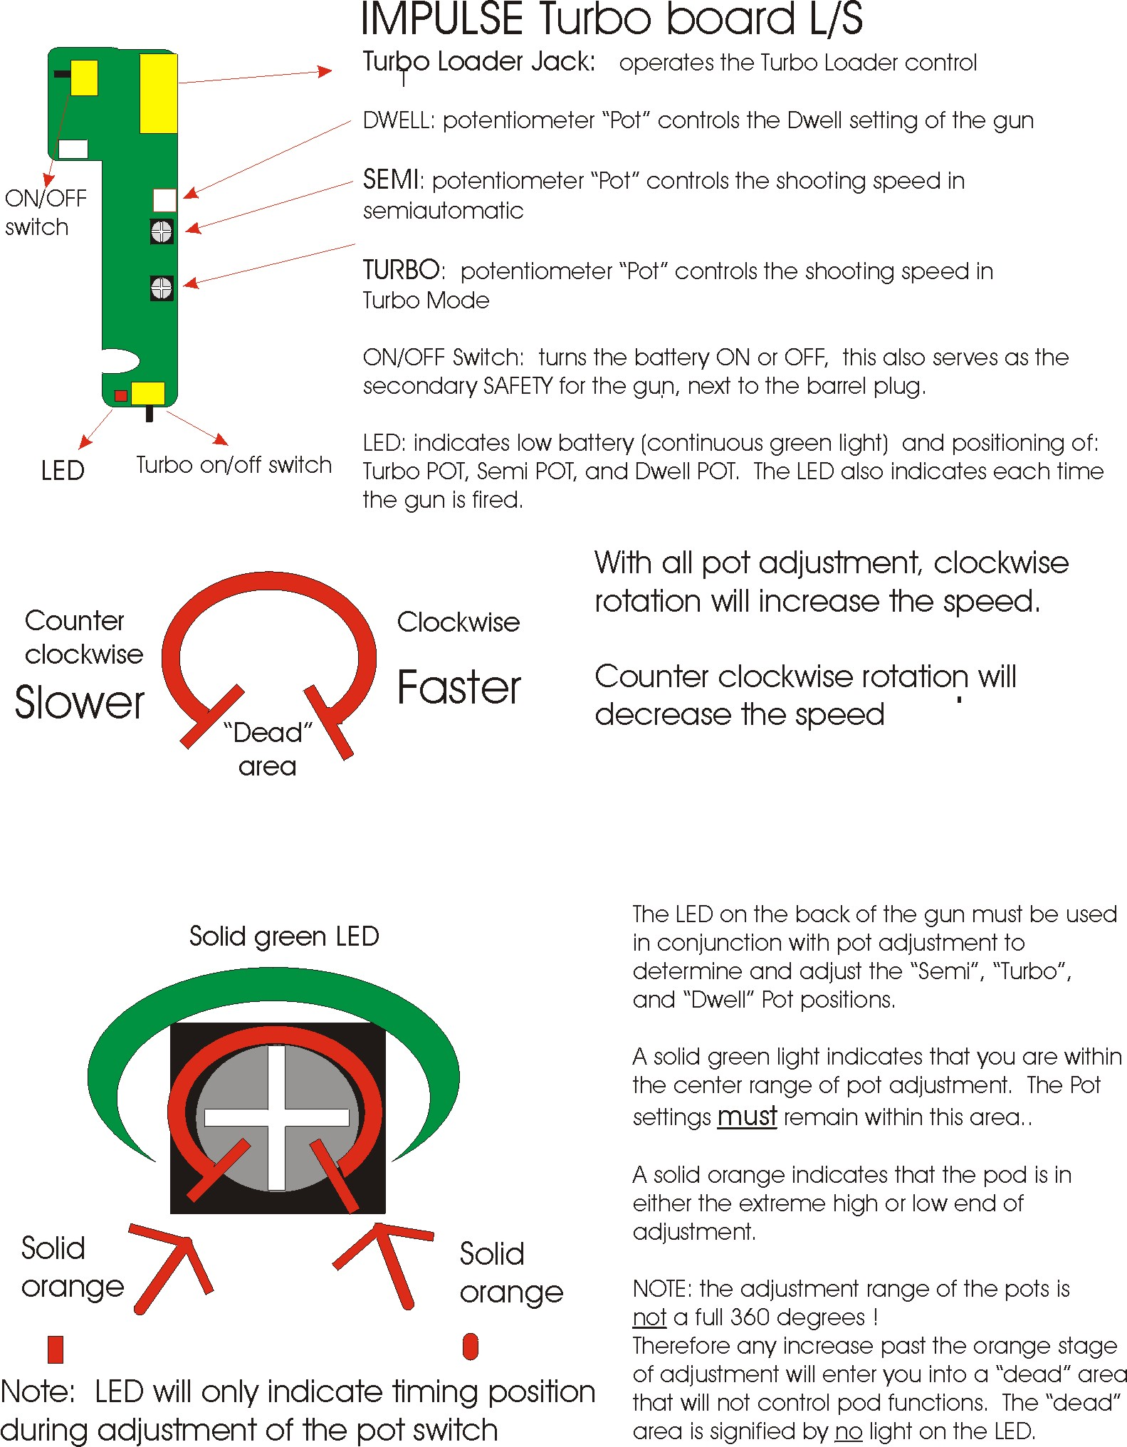
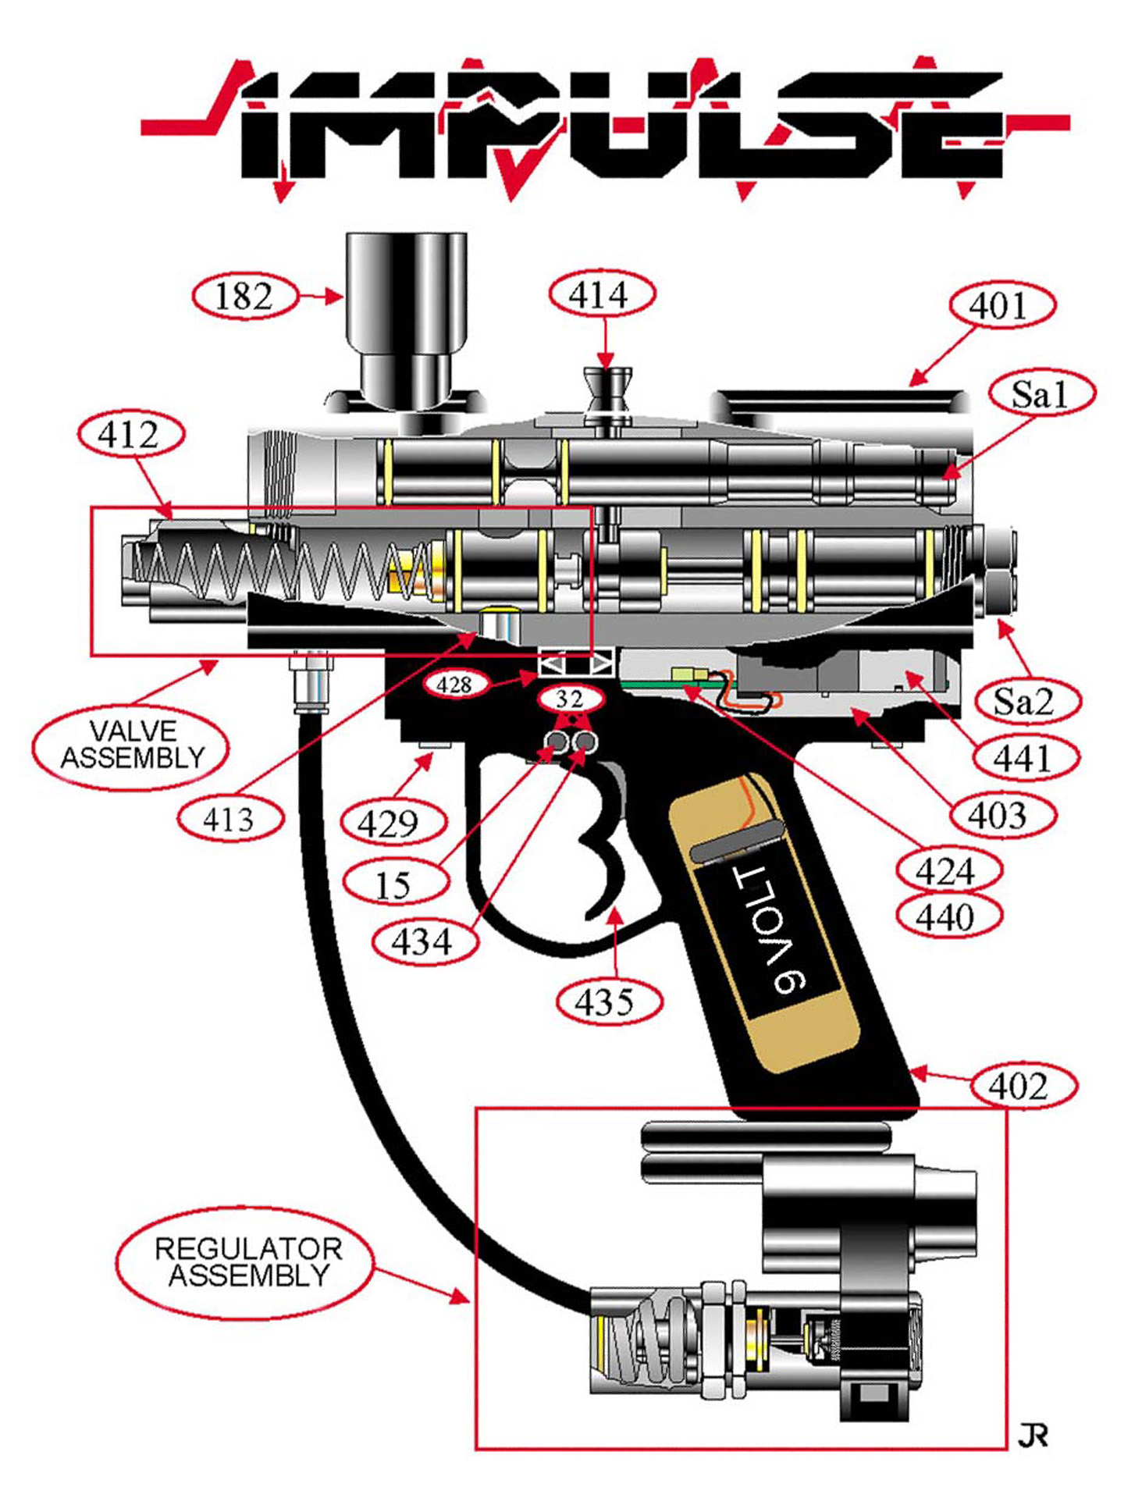
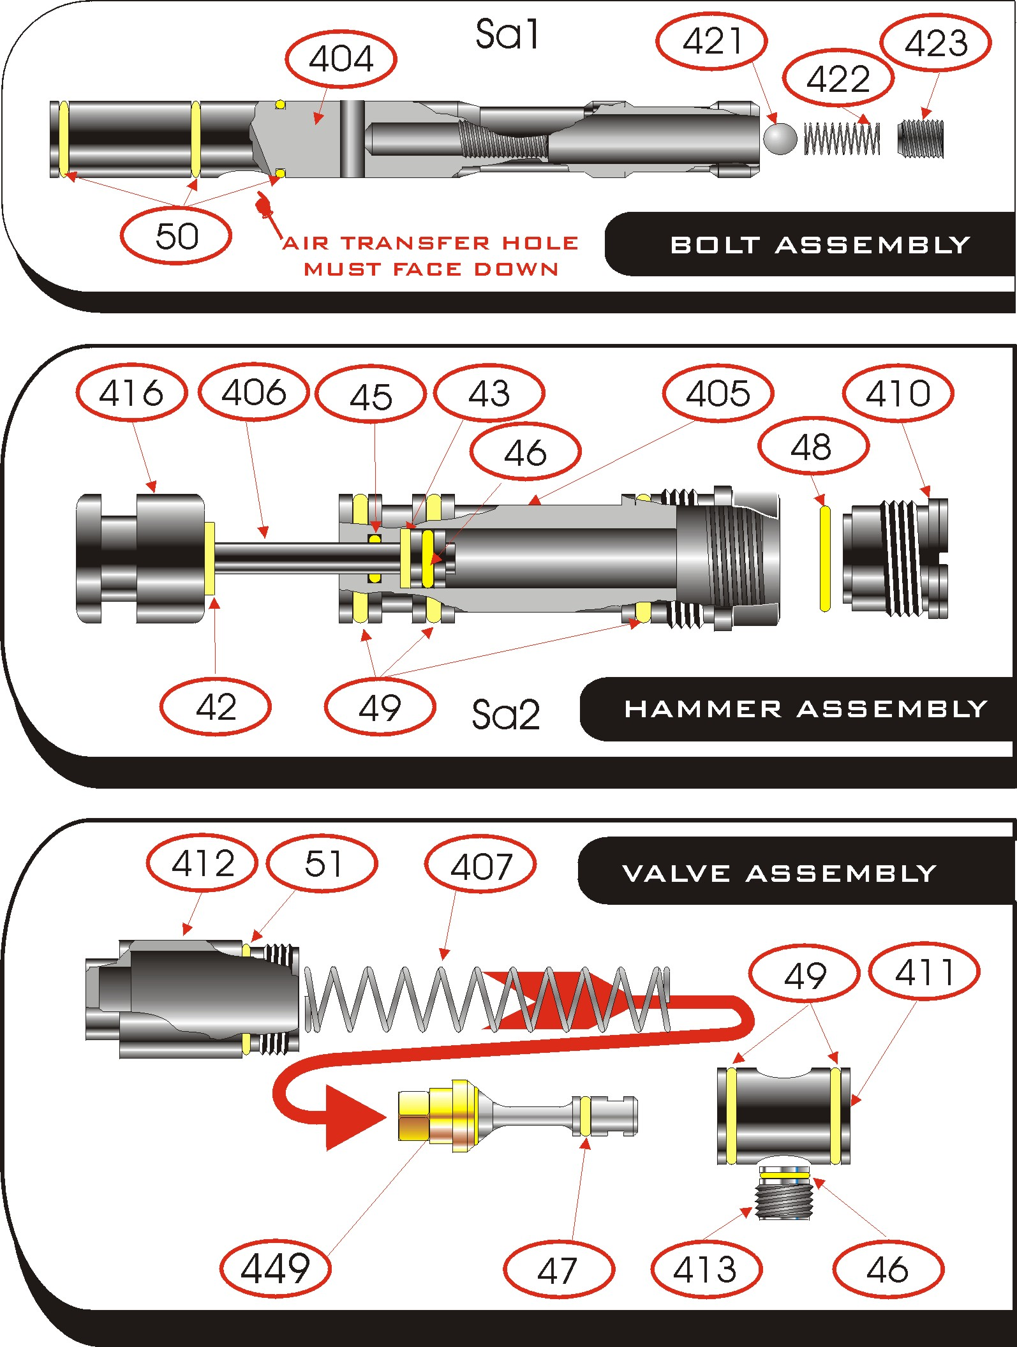
Impulse Parts List

Impulse body | 401 |  | Solenoid housing | 403
Ball feed tube | 182 |  | End cap | 412
Bolt location pin | 414 |  | Double trigger | 435
Trigger stop pin | 434 |  | Grip frame | 402
Trigger pin | 15 |  | Standard board | 424
Ball detent (nylon) | 426 |  | Turbo board | 460
On/Off Switch plate | 428 |  | Solenoid | 441
Board screws | 425 |  | Grip screws | 38
Filter 6” | 427 |  | Elbow (air hose slip fit) | 77
Grip frame screw | 429 |  | Air hose 5/16 nylon | 78
C-clip | 32
Bolt Assembly
Bolt | 404 |  | Locator ball spring | 422
Bolt seals | 50 |  | Bolt locator ball | 421
Locator ball screw | 423
Hammer Assembly
Hammer piston | 406 |  | Hammer cylinder cap | 410
Hammer piston seals (inner) | 45 |  | Hammer piston bumper (inner) | 43
Hammer cylinder cap seal | 48 |  | Hammer | 416
Hammer cylinder | 405 |  | Hammer piston seal | 46
Hammer piston bumper (outer) | 42 |  | Hammer cylinder seal | 49
Valve Assembly
End cap | 412 |  | Valve stem seal | 47
End cap seal | 51 |  | Valve assembly  (stem & cap) | 449
Valve seat | 411 |  | Valve seat locator | 413
Valve seat locator seal | 46 |  | Valve seat seal | 49
Valve spring | 407
Regulator Parts List
Regulator Retaining Nut | 212 |  | Poppet Guide | 209
Regulator Poppet Seal | 231 |  | Poppet Guide Seal | 50
Spring Retainer | 207 |  | Filter | 211
Poppet Spring | 206 |  | Regulator Poppet | 205
Seat cap | 203 |  | Regulator Seat Seal | 233
Seat base | 204 |  | Poppet Seat Seal | 46
Regulator Body | 202 |  | Regulator Lock Nut | 224
Regulator relief seat seal | 232 |  | Regulator Piston | 214
Regulator Piston Seal | 217 |  | Spring Guide Pin | 219
Regulator Spring | 230 |  | Regulator Spring Washer | 223
Regulator Screen | 222 |  | Regulator Cover | 225
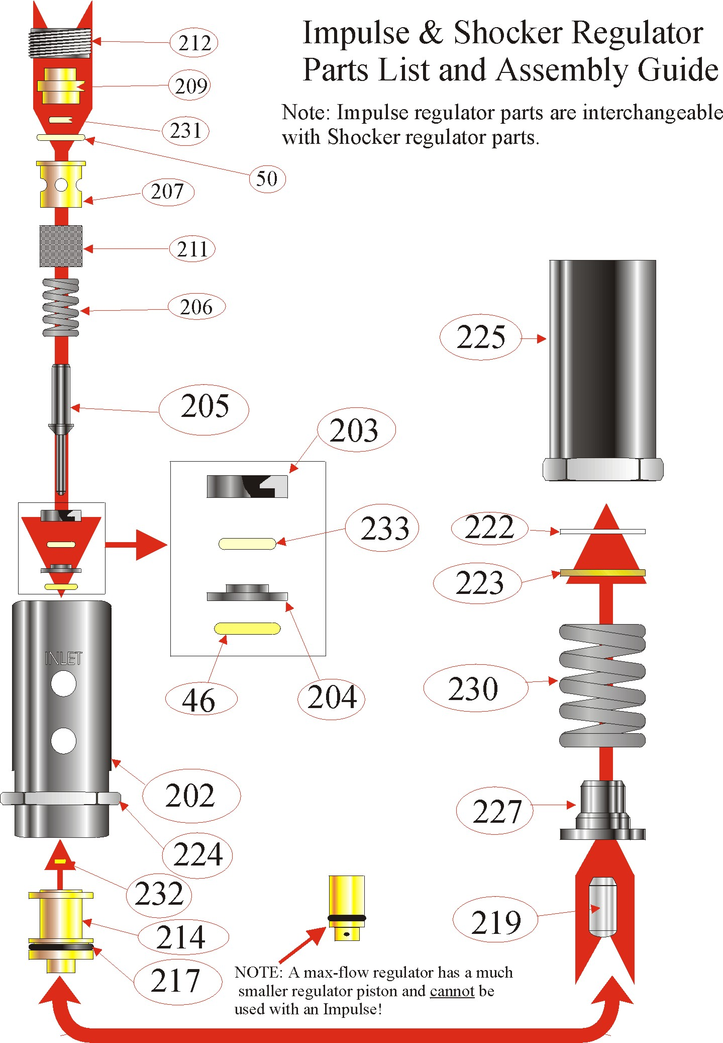
Trouble Shooting

PROBLEM | SOLUTION
1. Gun skips shots | - Check LED light (on back of gun) to see if it is green, indicating that your battery will need to be replaced.  - Check the gun and the regulator for air leaks..  - Make sure your loader is feeding paintballs as fast or faster than the gun is shooting. (Smart Parts recommends using a 12-volt Revolution loader.)  - Check to see if your barrel is the appropriate bore size for the paint you are using¹.  - Check to see if ball detent is missing or jammed.
2. Air leaks down the barrel | - Remove valve assembly and check the o-rings and the valve spring for twisting or damage. Re-lubricate and re-install.  - Shoot the gun 4 or 5 times to make sure the o-rings have seated correctly.
3. Bolt cycles but gun doesn’t fire. | - Check to see if the air transfer hole in the bolt is facing down.  - Check to see if the bolt remains in the forward position after firing, this indicates that the bolt location pin is not connected to the hammer.  - Check the LED light on the back of the gun. If green, you will need to replace the battery.  - Check the pressure coming into the gun to ensure it is above 150psi. Also check your tank is not empty.  - Make sure there are no air leaks in the gun or attachments. If there are, locate and repair them.  - Check solenoid valve for contamination (SH4000). Call Smart Parts for assistance².  - Dwell setting may be too low.  - Valve seat locator (#413) may be overtightned.
4. Air leak on the inside of the gun | - Remove the two screws from the solenoid housing and split the gun in half. Check the solenoid screws to ensure they are snug, but use caution not to over-tighten and strip threads.  - With the body separated from the grip assembly, gas up the gun and try to locate the exact location of the leak. Call Smart Parts if assistance is needed².
5. Inconsistent velocity | - Clean your barrel.  - Point barrel upward to keep the ball from rolling out of the breach of the gun.  - Check your paint to see if it fits your barrel properly¹.  - Check regulator and gun for leaks.  - Check fire valve o-ring for cuts and nicks.  - Check your bottle valve to ensure it is open completely.  - If velocity will only reach 250fps at a high pressure (about 220psi), the middle section of the SH4000 solenoid is clogged with dirt and will need to be replaced.

- The proper way to check to see if you barrel’s bore is the right size for the paint you are using is to insert a paintball into the barrel you are using. Try to blow the ball out of the barrel. If the ball is extremely hard to blow out or if it won’t move at all, your bore size may be too small or your paint may be too large. If your ball rolls out the barrel easily, your paint may be too small or your barrel may be too big. If you can blow the ball out of the barrel with minimal force then your bore size is just right. Note: It is best to try this with a number of paintballs as they may vary from ball to ball.
- Please call Smart Parts at 1-800-992-2147. How-to guides are also available at http://www.smartparts.com. When calling Smart Parts, make sure you have your gun and tools in front of you in order to remedy problem.

Anti-siphon Information

An anti-siphon tube is a tube that is installed in a CO₂ tank’s valve in order to help prevent liquid CO₂ from entering the system. The tube is screwed into the back of the valve and bent so that the end of the tube will be pointing up when the tank is screwed into the gun. When the valve is completely screwed into the gun mark an “X” on the outside of the valve (or on the outside of the tank) near the neck to indicate the up position of the tube inside the tank and to also show that the tank is an Anti-Siphon Tank. NOTE: Tanks with anti-siphon tubes should only be used on the cradle or fitting that it was set-up for. If you use an anti-siphon tank on a different bottle adapter, there is a good possibility that the tube will be oriented incorrectly and draw liquid CO₂. Anti-siphon equipped tanks should never be used on remote systems.

Anti-siphon tubes should only be installed by QUALIFIED AIRSMITHS. Please do not attempt to install an anti-siphon tube on your tank, have a professional install it for you. If you need more information regarding this matter please feel free to contact your local paintball field or Smart Parts at (724) 539-2660.

Disassembly/Reassembly Instructions

Disassembly of Bolt

- Remove bolt location pin (#414) and pull bolt from back of gun.

Reassembly of Bolt

- Apply a light coating of grease to the bolt o-rings,
- When reinstalling, be sure that air transfer port is facing down !
- To properly reinstall the bolt location pin, the bolt must be in the back position to allow the pin to fit into the hammer properly.
(if the bolt location pin is not positioned properly to attach the bolt to the hammer, the bolt will remain forward after being cycled)

Disassembly and Cleaning of the Solenoid
BE SURE THAT GUN IS DEGASSED AND BATTERY IS REMOVED BEFORE STARTING!!!
- Using a small phillips head screw driver, remove the black cap at end of solenoid (positioned at the silver end of solenoid),
- When removing cap notice the line on the bottom of the cap (the cap MUST be reassembled with the line facing down or solenoid will leak!!),
- When the cap is taken off remove the cone shaped spring,
- Using a pair of needle nose pliers pull the shaft out of the solenoid and inspect shaft o-rings for damage or debris.

Reassembly of Solenoid:

- Grease solenoid shaft and o-rings with a generous amount of dow 33 lubricant only!
- Reinsert solenoid shaft with pointed end facing out.
- Place cone shaped spring over shaft with small end facing shaft,
- Place cap over spring and shaft (with line on cap facing down) and reinsert phillips head screws.
- Snug down screws – DO NOT OVER TIGHTEN!!!

For illustrated step by step instructions, see the “How to guide” at our web site, www.smartparts.com.
Gun Will Not Fire

Check Battery
If good, check to see if battery is turned on, continue.
If bad, replace…
LED will remain green
to signify low battery.

Still not working…
Split gun, check wires for breaks or crushed.
If smashed, reposition wires and try again…
Still not working…
Press manual button on SH4000 solenoid. If the gun fires, try pulling the trigger.
If the gun works with the manual button, but not with the trigger…
If the gun does not work at all…
The problem could be a bad coil or bad electronic board.
Replace or call Smart Parts.
The solenoid must have dirt in it, or the pilot in the solenoid must be plugged. See cleaning instructions or call Smart Parts.
Check to see that bolt is properly positioned with the air transfer port facing down. Also check to see that bolt location pin is connected to the hammer. The bolt remaining forward after being fired indicates that the bolt is not connected to the hammer. Reposition and try gun again.
Still not working…
That worked!
Make sure hammer assembly is screwed all the way in. Remove valve end cap and check valve & spring for damage or wear. Try gun again.

